**Search Data With ReactJS (HOOKED)**

1. **Cách tạo project**

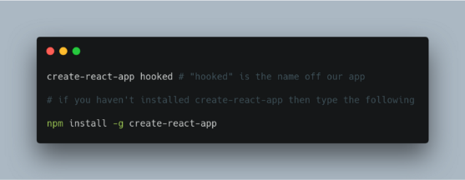

1. **Dùng hook**
2. **Trang App.js**

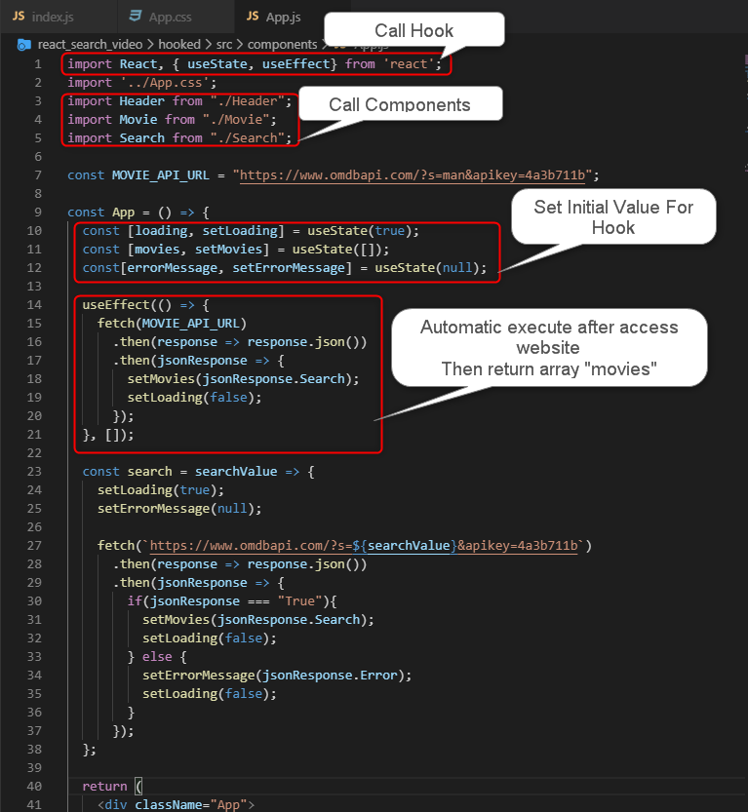

1. **Pass and Get value From another Component**

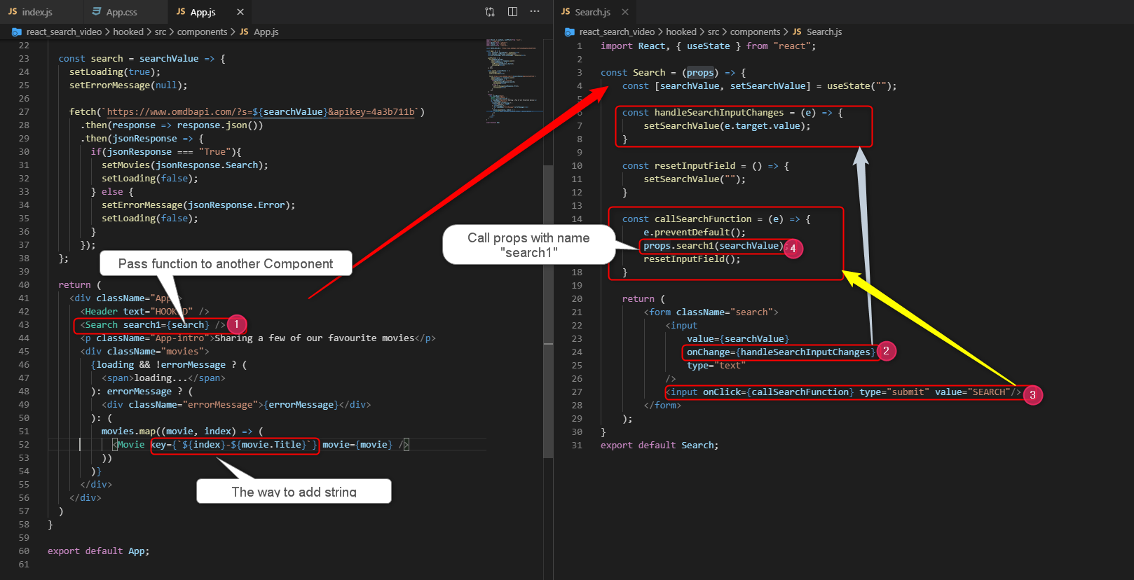

* **Show interface by Component**

